TP3

Service Oriented Architecture

Mohamed Ali Bouri – LSI3 1.2

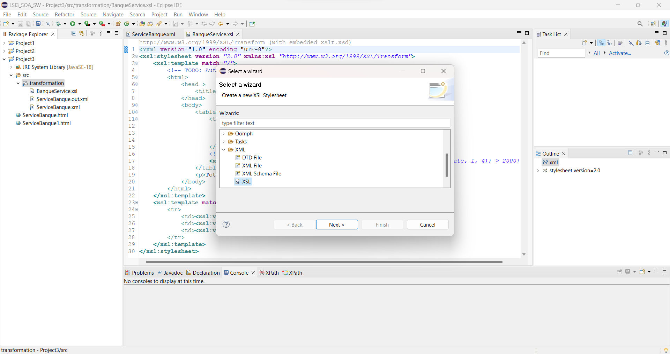

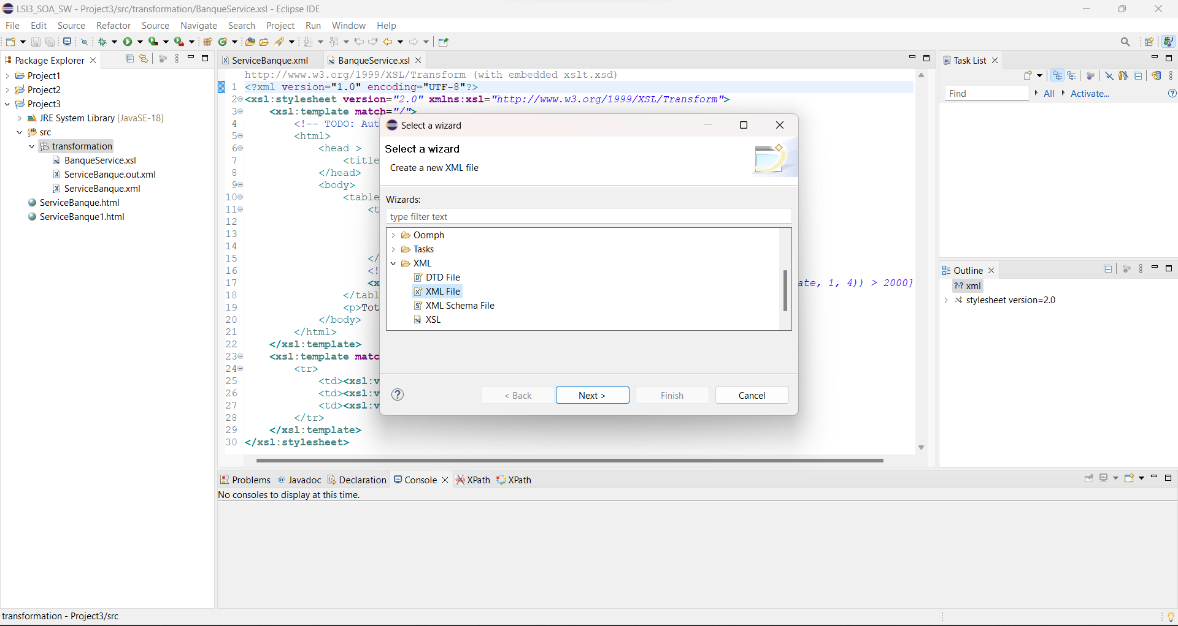

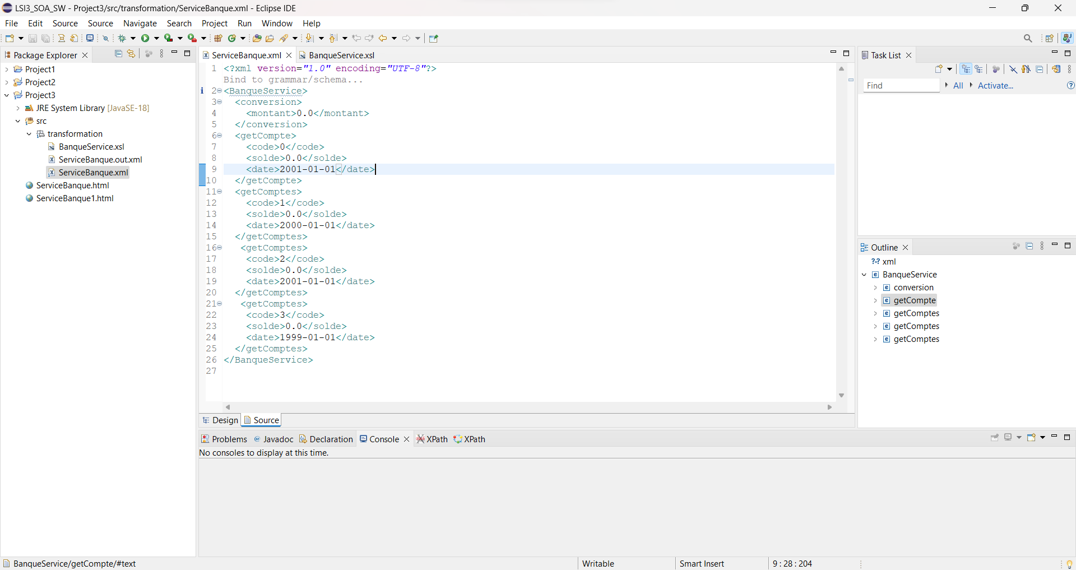

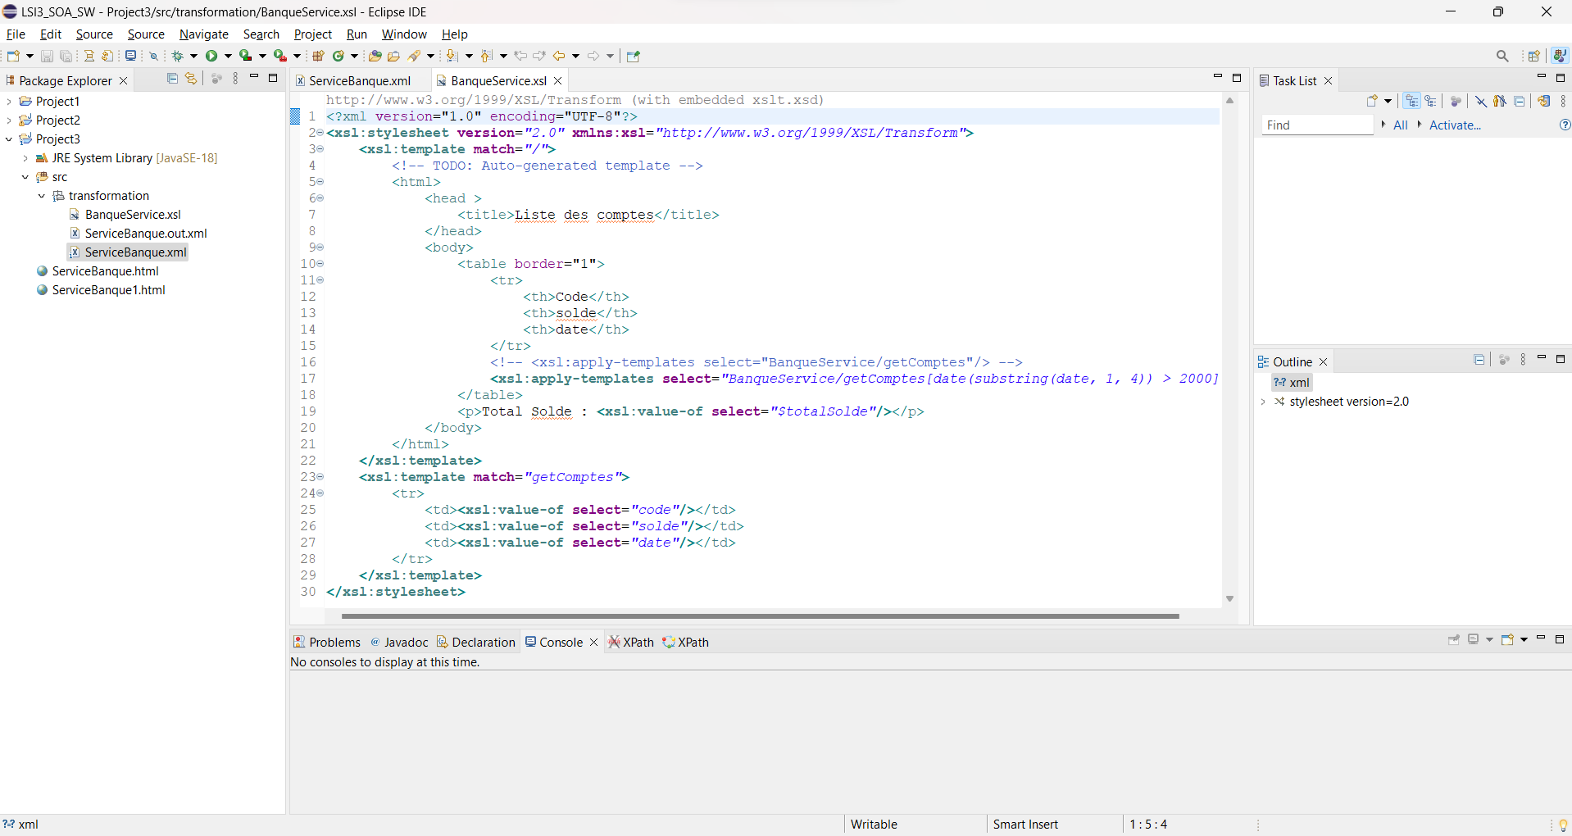

**Lien GitHub :**

https://github.com/Mohamedalybouri/soa